Kesners, Arthur (mainly based on CALM News 1987)
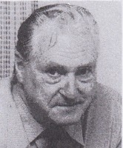
Joined Forests Department in 1954, as Forests Assistant at Grimwade. Transferred to Forest Department Dwellingup 1964-65. To Wanneroo 1966-73, then District Forester in Dwellingup 1974-77. Appointed Departmental Safety Officer, based in Forests Department Como in 1978. In 1986 on special duties looking at workers compensation procedures. Retired 1987, after almost 10 years as Departmental Safety Officer.

